**Dapper Vs Entity Framework Core 2.0 Performance Benchmark:**

**Environment:**

We have used **benchmarkdotnet** nugget for performance measurements.

Sample database was NowMobileRep, users_general contains 500000 rows.

1. For 100 records(select top 100 * from users_general)

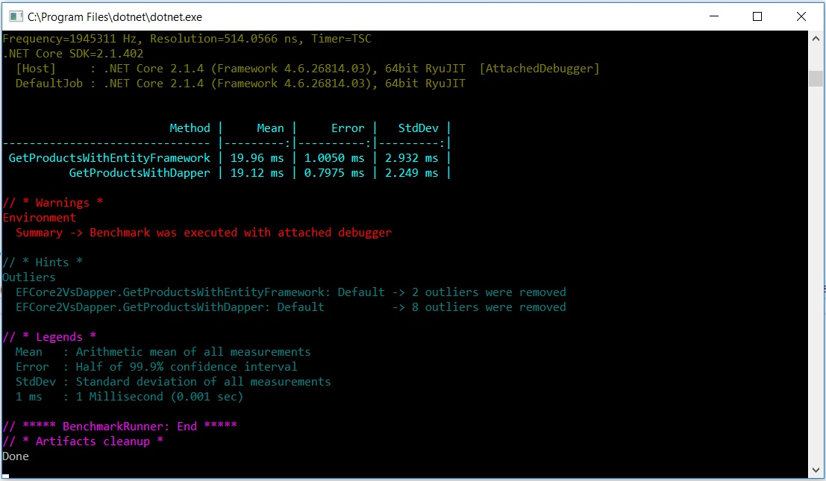

1. For 5000 records(select top 5000 * from users_general)

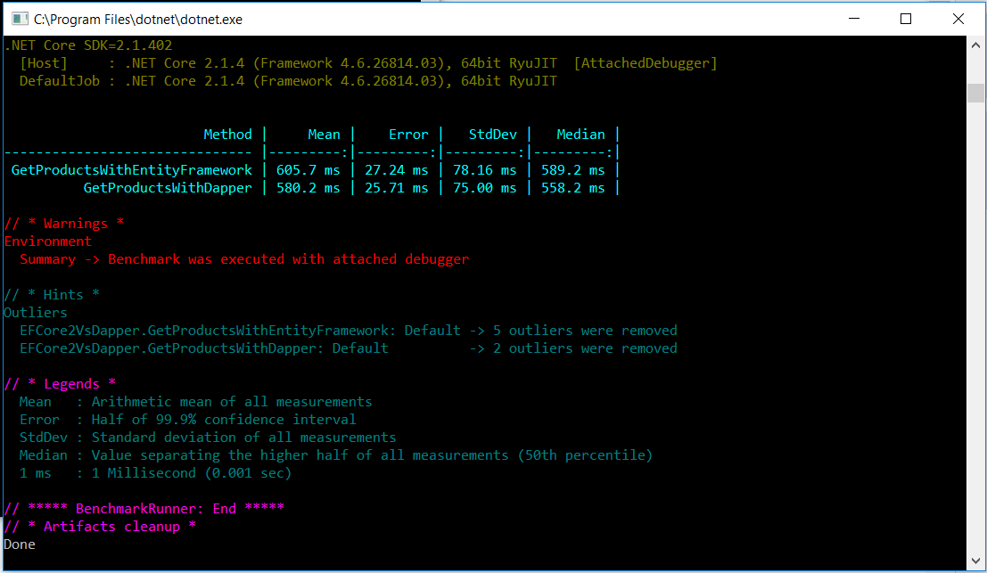

**Final Thoughts:**

**Dapper is still faster, but the difference for a simple select inline query is very minimum for EF Core 2.0.**

**.AsNoTracking() in EF for read operations should be applied for more performance benefit.**